**Applecross Senior High School**



**Western Australian Certificate of Education**

**Semester One Examination, 2017**

**Question/Answer Booklet**

|  |  |  |  |
| --- | --- | --- | --- |
|  | **Total** | **Result** | **_____%** |
| **Section One** | **52** |  |
| **Section Two** | **96** |  |
| **Total** | **148** |  |

**MATHEMATICS:**

**SPECIALIST**

**UNIT 1**

**Section One:**

**Calculator- free**

**Student’s Name**: **_______________________________________**

**As shown on your exam timetable**

**Student’s Teacher Ms Coffey Mrs Waddell**

(**Circle your teacher’s name**.)

**Time allowed for this section**

Reading time before commencing work: five minutes

Working time for this section: fifty minutes

**Materials required/recommended for this section**

***To be provided by the supervisor***

This question /Answer Booklet

Formula Sheet

***To be provided by the candidate***

Standard Items: pens (blue/black preferred), pencils (including coloured), sharpener,

correction fluid/tape, eraser, ruler, highlighters.

Special items: nil.

**Important note to candidates**

No other items may be taken into the examination room. It is **your** responsibility to ensure

that you do not have any unauthorized notes or other items of a non-personal nature in the

examination room. If you have any unauthorized material with you, hand it to the supervisor

**before** reading any further.

|  |  |  |  |  |  |  |
| --- | --- | --- | --- | --- | --- | --- |
| Section | Number of questions available | Number of questions to be answered | | Working time (minutes) | Marks available | Percentage of exam |
| Section One:  Calculator-free | 6 | 6 | | 50 | 52 | 35 |
| Section Two:  Calculator-assumed | 12 | 12 | | 100 | 96 | 65 |
|  | | | **Total** | | 148 | 100 |

## Instructions to candidates

1. The rules for the conduct of examinations are detailed in the *School Examination Rules* provided with your exam timetable.Sitting this examination implies that you agree to abide by these rules.
2. Write your answers in this Question/Answer Booklet.
3. You must be careful to confine your responses to the specific questions asked and to follow any instructions that are specific to a particular question.
4. Spare pages are included at the end of this booklet. They can be used for planning your responses and/or as additional space if required to continue an answer.

* Planning: If you use the spare pages for planning, indicate this clearly at the top of the page.
* Continuing an answer: If you need to use the space to continue an answer, indicate in the original answer space where the answer is continued, i.e. give the page number. Fill in the number of the question(s) that you are continuing to answer at the top of the page.

1. **Show all your working clearly**. Your working should be in sufficient detail to allow your answers to be checked readily and for marks to be awarded for reasoning. Incorrect answers given without supporting reasoning cannot be allocated any marks. For any question or part question worth more than two marks, valid working or justification is required to receive full marks. If you repeat an answer to any question, ensure that you cancel the answer you do not wish to have marked.
2. It is recommended that you **do not use pencil**, except in diagrams.
3. The formula sheet and your notes are **not to be handed** in with your Question/Answer Booklet.

Section One: Calculator-free 35% (52 Marks)

This section has**six (****6)** questions. Answer **all** questions. Write your answers in the spaces provided.

Working time: 50 minutes.

Question 1 (7 marks)

It can be shown that for all $n≥0,$

$$^{n+1}P_{r}=\frac{n+1}{n-r+1}×{ ^{n}P}_{r}$$

(a) Show that the identity is true when $n=4$ and $r=2$. (2 marks)

Given that $^{8}P_{4}=1 680$, $^{12}P_{5}=95 040$ and $^{12}P_{6}=665 280$, evaluate

(b) $^{11}P_{6}$. (2 marks)

(c) $^{10}P_{4}$. (3 marks)

Question 2 (11 marks)

Three vectors are given by $a=3i-5j$, $b=-2i+7j$ and $c=6i+j$.

(a) Determine

(i) $a+b+c$. (1 mark)

(ii) $|c|$. (1 mark)

(iii) $2a+3b$. (2 marks)

(b) Determine the unit vector $\hat{d}$ that is parallel and in the same direction as $b-a$. (3 marks)

(c) Express $c$ in terms of $a$ and $b$. (4 marks)

Question 3 (8 marks)

(a) Write the inverse of the following true statement and comment on the truth of the inverse statement. (2 marks)

"If the discriminant of the quadratic formula is zero, then the quadratic has just one real root."

(b) Write the converse of the following true statement and comment on the truth of the converse statement. (2 marks)

"If $x>3$ then $x>2$."

(c) Determine the truth of the following statements, using an example or counter-example to support each answer.

(i) If $z∈R$ and $z^{3}$ is an even number then $z$ is an even number. (2 marks)

(ii) If $x,y∈Z$ and $x>y$ then $x^{2}>y^{2}$. (2 marks)

Question 4 (7 marks)

(a) A body moves from $P(2, -3)$ to $Q(-2, 1)$.

(i) Determine the displacement vector $\vec{PQ}$ in component form. (1 mark)

(ii) Determine the magnitude of the vector $\vec{PQ}$. (1 mark)

(b) A force of $6i-6\sqrt{3}j$ N acts on a body. Determine the magnitude of the force and the angle its direction makes with the positive $x$-axis. (2 marks)

(c) A body moves with a velocity of 20 ms-1 at an angle of 135° with the positive $x$-axis. Express the velocity of the body in the form $ai+bj$, where $a$ and $b$ are constants.

(3 marks)

Question 5 (10 marks)

(a) In the diagram below, not drawn to scale, $PQRS$ is a cyclic quadrilateral such that $PS=QS$, $∠RPQ=34°$ and $∠PQR$ is a right-angle.

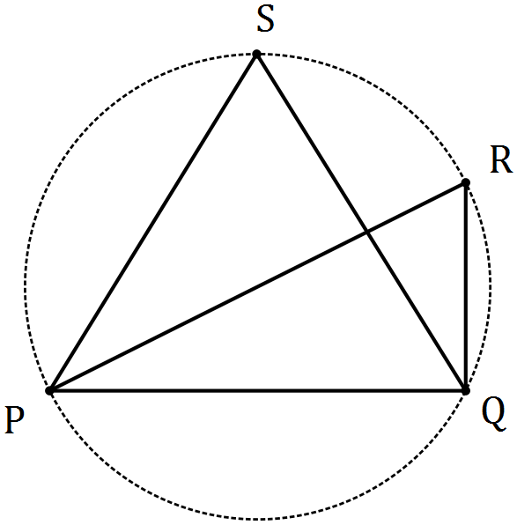

Determine the sizes of

(i) $∠PSQ$. (2 marks)

(ii) $∠RPS$. (2 marks)

(b) In the circle with centre $O$ drawn below, chord $AC$ intersects chord $BD$ at $E$. Explain, with reasoning, why triangles $AED$ and $BEC$ are similar. (3 marks)

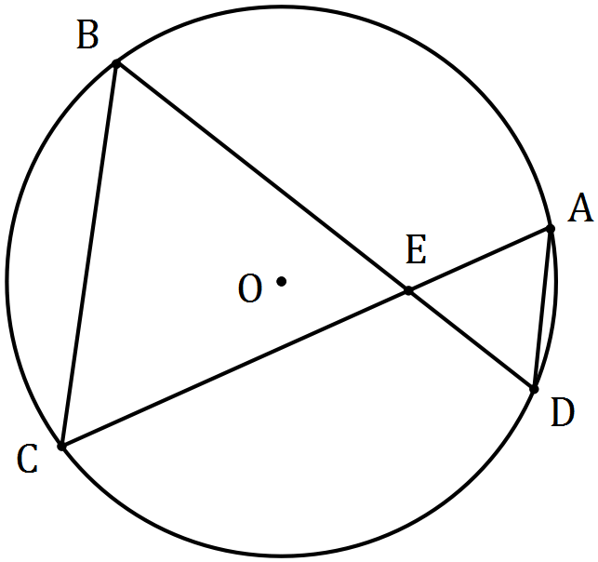

(c) Prove that when two chords of a circle intersect, the product of the lengths of the intervals on one chord equals the product of the lengths of the intervals on the other chord.

(3 marks)

Question 6 (9 marks)

(a) Determine the number of different four-letter passwords that can be made by arranging a selection of four letters chosen from the list P, Q, R, R, R, R and S. (4 marks)

(b) How many different whole numbers can be made from the digits 0, 1, 2, 3 and 4? (5 marks)

**Additional working space.**

**Question Number: _________**

**Additional working space.**

**Question Number: _________**